
Kathmandu College of Technology
Lokanthali, Bhaktapur

Lab report on
Computer fundamentals and applications (CACS-101}
As required for the partial fulfillment of
BCA 1st Semester
Affiliated to Tribhuvan university

Submitted by Submitted to
Smriti Shrestha Department of BCA
Roll no: 25

CERTIFICATE FROM THE SUPERVISOR

I hereby affirm that the Lab Report titled "Computer Fundamentals and Application" is an academic undertaking carried out by 'SMRITI SHRESTHA' as part of the partial fulfillment of the requirements for the degree of Bachelor of Computer Application at the esteemed Faculty of Humanities and Social Sciences, Tribhuvan University, under my unwavering guidance and supervision. To the best of my discernment, the content presented in the Lab Report is the original work of 'SMRITI SHRESTHA' and reflects her individual effort and ingenuity in the field.

Signature of the Supervisor: -
Name: -
Designation: -
Date: -
ACKNOWLEDGEMENT

I would like to extend my heartfelt appreciation to Prajwol sir and the entire faculty of Humanities and Social Sciences for providing me with the opportunity to complete this project. I am immensely grateful for the support and guidance received during the course of my studies.
The requirement to submit this report stems from the guidelines set forth by Kathmandu College of Technology (KCT), where it is mandatory to obtain practical marks. Our esteemed teacher for Computer Fundamentals and Application has been a constant source of motivation, providing valuable insights on how to structure and prepare the report to achieve optimal results. I am particularly grateful to all my fellow BCA students who were actively engaged in this endeavor.
This report is intended to be a valuable resource for future reference, and I am committed to delivering a high-quality output in accordance with the academic standards set forth by KCT.

Thank You

Contents
A. Word Processing Software 5
1. Write an application to apply the post of Java programmer with your bio-data 5
2. Prepare any type of form to fill up user’s detail in any word processing software. 7
3. Prepare a two months’ calendar using table. 7
4. Design a well-formatted newspaper page containing text, pictures, drop cap, charts, etc. 10
5. Design an attractive advertisements using Photoshop. 11
6. Design an ID card for your college using Photoshop 12
7. Prepare your passport size photo with white background in Photoshop. 13
14
B. Spreadsheet software 15
8. Create a marks ledger of 10 students as per the following conditions: 15
9. Prepare a bill of at least 10 items 16
10. Create a salary sheet of at least 7 staffs in the office along with graph and chart 17
C. Presentation software 19
11. Prepare a presentation including at least 10 slides of any topic of your choice related to Information Technology. 19
D. Operating system 24
12. Create a file named “BCA.txt” under your currently created directory. The file should contain the text “We are in computer lab”. 24
13. Create files and folder according to the below chart. 25

Word Processing Software
- Write an application to apply the post of Java programmer with your bio-data.
Madhyapur thimi-4, Bhaktapur
Province no: 1
2079/12/03
Mr. Jack Mullin
Oracle Corporation
Oracle parkway
Redwood shores, ca 94065
Sub: Application for post of Graphic Designer
Dear Sir,
I am very interested in the position of Graphic Designer at your esteemed organization. I came across the position via your advertisement in New York Times.
I believe that I can give my best for your company; I am confident that I have the skills to excel at your dynamic organization. I have always dreamed of being a part of your company due to the development opportunities you provide. I request you to give me an opportunity to learn and grow at your esteemed firm through this job role.
I am confident that my skills perfectly match your requirements. I have also attached a copy of CV with this application,
Thank you for considering my application. I hope you find it suitable so that we can arrange a meeting. I look forward to hearing from you.

Yours sincerely,
Smriti Shrestha
9818986530
Smritishrestha058@gmail.com
Smriti Shrestha
Bhaktapur, Nepal | 9823525425 | Email: smritishrestha058@gmail.com

Objective
To pursue my career in an organization with total effort and devotion with an ambition to rise to the top management where my abundant skills and full academic potential would lay a foundation for my career.

Education
2022-present: Bachelor in computer Application
Field of study: BCA
Kathmandu College of Technology

2020-2022: Plus 2
Field of Study: Management
Supreme Academy H.S.S

Experience and Internship
R.D Auto Trade
Service Department Operator
Responsibilities:
- Customer Handling
- Cash Management
- Stock Management

Skills
- Excellent Written and verbal communication skills
- Excellent MS-Office knowledge
- Can handle the work pressure and can work in any kind of scenario as suggested

Declaration
All over information has been completed by me and is accurate.

Prepare any type of form to fill up user’s detail in any word processing software.


Reg no ______________

3. Prepare a two months’ calendar using table.
1.Name:

2. Father’s Name:
3. Gender: Male Female
4. Date of Birth:
5. Phone no:
6. Nationality:
7. Address:
Province
District
Municipality
Ward No

Student’s Signature
Principal’s Signature

Paste you recent
Password size photo here
ADMISSION FORM
For office use:
Course: _____________________________
Admission Date: ______________________

Baishakh 2080 April/May
Sunday | Monday | Tuesday | Wednesday | Thursday | Friday | Saturday
 |  |  | 1  16 | 2  17 | 3  18 | 4  19
5  20 | 6  21 | 7  22 | 8  23 | 9  24 | 10  25 | 11  26
12  27 | 13  28 | 14  29 | 15  30 | 16  1 | 17  2 | 18  3
19  4 | 20  5 | 21  6 | 22  7 | 23  8 | 24  9 | 25  10
26  11 | 27  12 | 28  13

Holidays: -
19 February: Democracy Day

Jestha 2080 May/June
Sunday | Monday | Tuesday | Wednesday | Thursday | Friday | Saturday
 |  |  | 1  14 | 2  15 | 3  16 | 4  17
5  18 | 6  19 | 7  20 | 8  21 | 9  22 | 10  23 | 11  24
12  25 | 13  26 | 14  27 | 15  28 | 16  29 | 17  30 | 18  1
19  2 | 20  3 | 21  4 | 22  5 | 23  6 | 24  7 | 25  8
26  9 | 27  10 | 28  11 | 29  12 | 30  13 | 31  14

Holidays: -
21 March: Ghode Jatra
6 March: Holi
- March: Women’s Day

- Design a well-formatted newspaper page containing text, pictures, drop cap, charts, etc.

Tuesday, April 11, 2023
A singer’s untold story
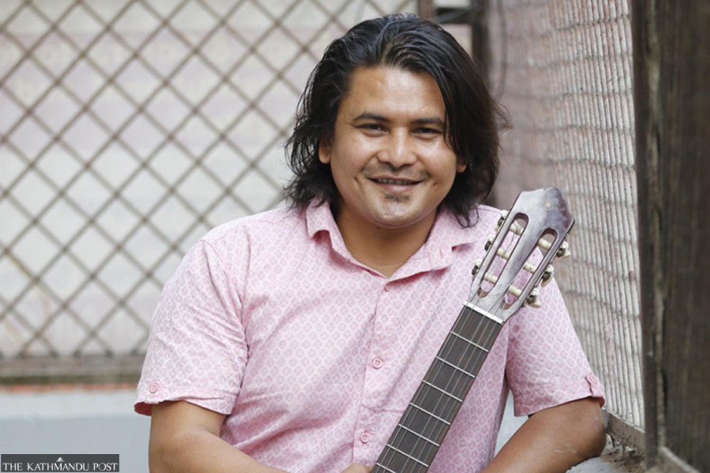Musician Arjun Kaushal opens up about his unstable career and the many challenges he has overcome on his journey. Arjun Kaushal has been active in the music industry for over three decades, but the composer, lyricist and singer still finds it difficult to sustain himself in the field. Kaushal isn’t a formally trained musician and having worked so long in the music industry, he feels formal training isn’t necessary for people who want to pursue a career in it. “At the beginning of my career, I just knew the eight notes—’Sa Re Ga Ma’. But that didn’t stop me. I immersed myself in the field and picked up skills through regular practice,” he says.

Will UML help the coalition on transitional justice bill?
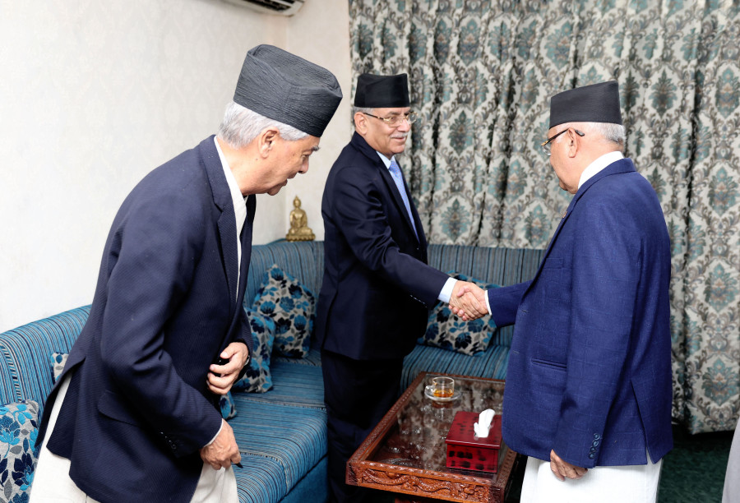
As the ruling parties want to fast-track the bill, the role of the second-largest party is being keenly watched. Seventeen years have passed since the peace process began following the signing of the Comprehensive Peace Accord in 2006. But major political parties are still blaming each other for the delay in concluding the process. Needed amendments to the laws have not been made while the two commissions created to provide justice to the insurgency victims remain largely ineffective?

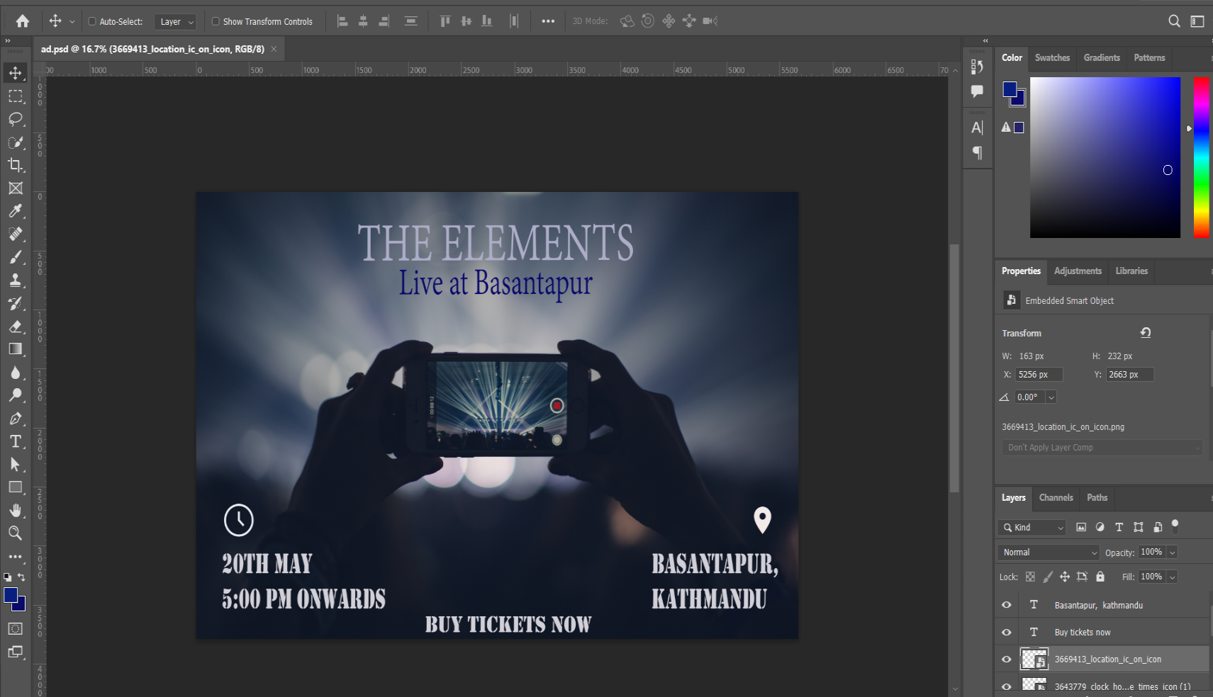
5. Design an attractive advertisements using Photoshop.
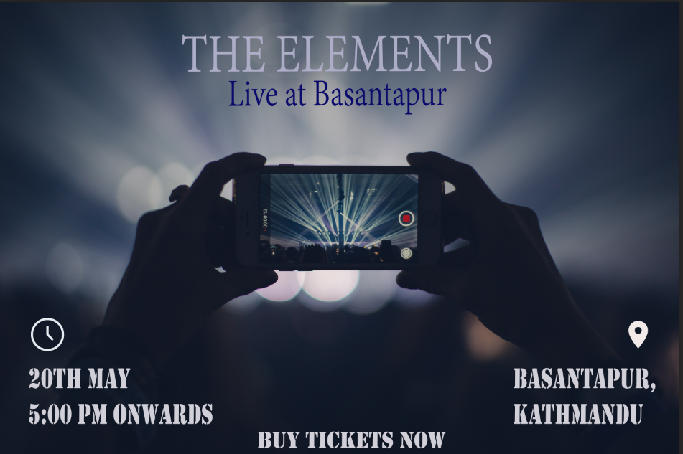
Final Result
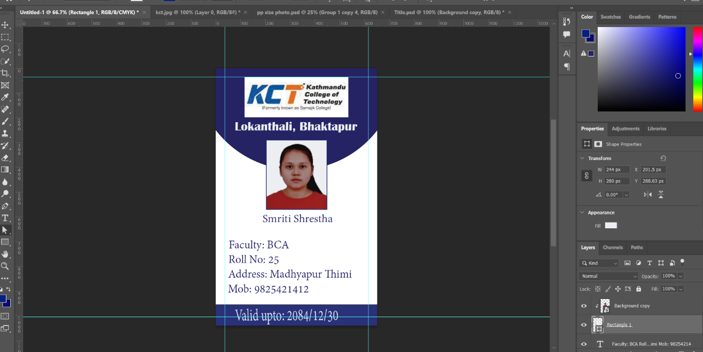
6. Design an ID card for your college using Photoshop.

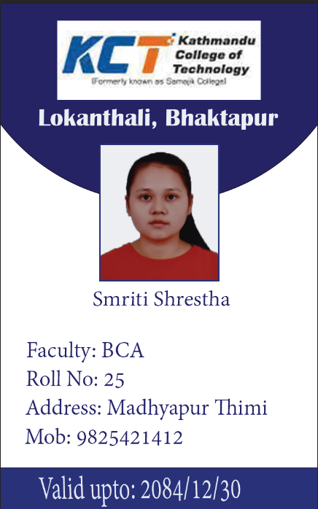
Final Result:

7. Prepare your passport size photo with white background in Photoshop.

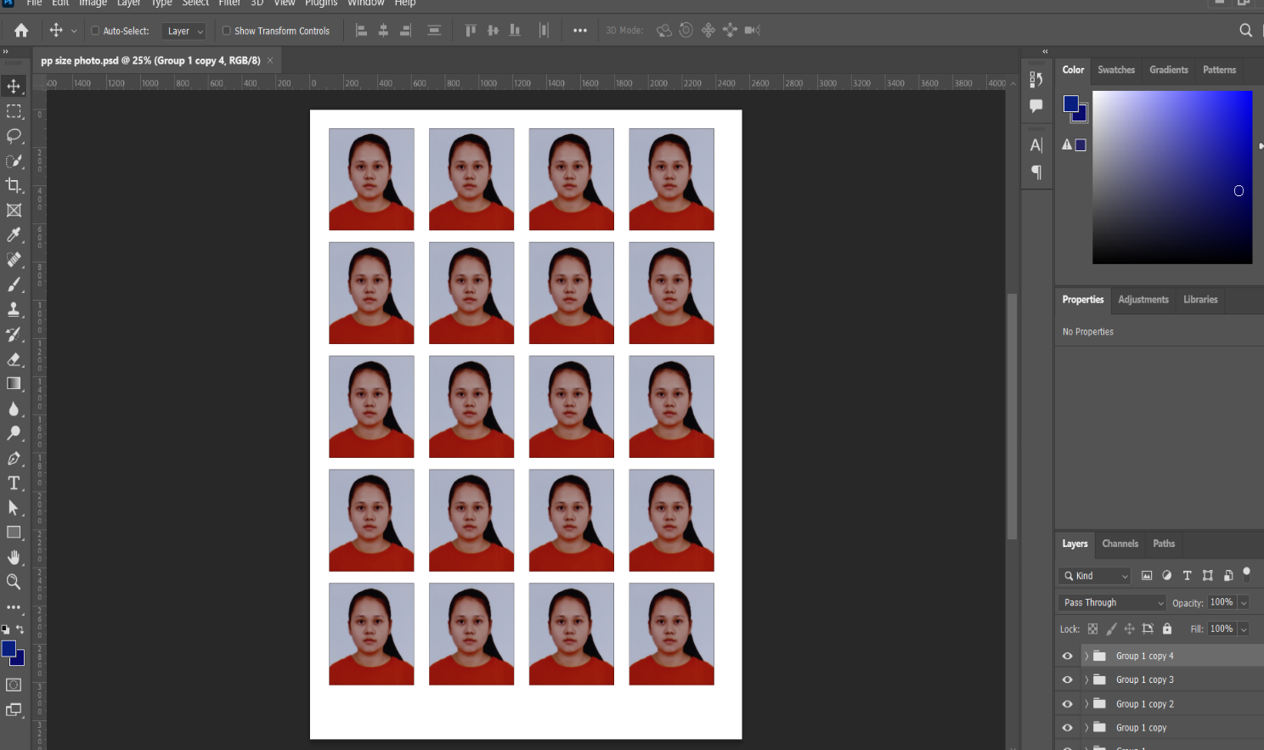

Final Result:
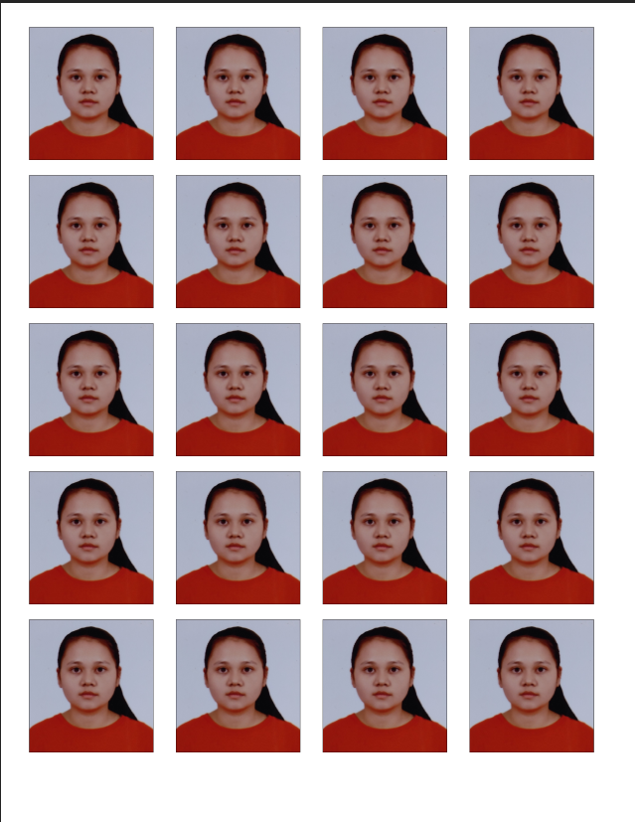

B. Spreadsheet software

8. Create a marks ledger of 10 students as per the following conditions:
a) Calculate total marks
b) Calculate result, whether the student has passed or failed the examination.
c) Calculate the percentage of each student.
d) Calculate the grade of each student where 90-100% is A+, 80-90% is A, 70-80% is B+,
60-70% is B, 50-60% is C+, 40-50% is C and <40 is non-graded that is “NULL”.
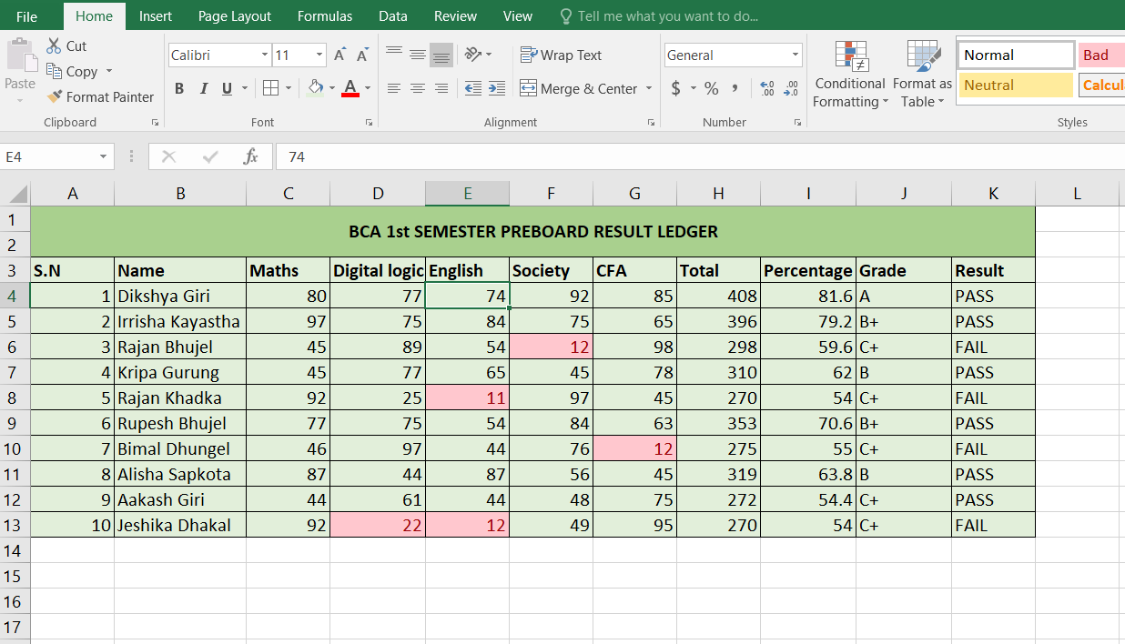

Formulas used:
Total: =SUM (C4:G4)
Percentage: =H4/5
Grade: =IF(I4>=90,"A+",IF(I4>=80,"A",IF(I4>=70,"B+",IF(I4>=60,"B",IF(I4>=50,"C+",IF (I4>=40,"C",IF(I4<=39,"NULL")))))))
Result: =IF(MIN(C4:G4)>=24,"PASS","FAIL")
9. Prepare a bill of at least 10 items under the given conditions:
a) Enter the quantity and rate as per your choice.
b) Calculate the total amount of each.
c) Calculate Net Total, discount amount (5%), tax amount (13%) and grand total.
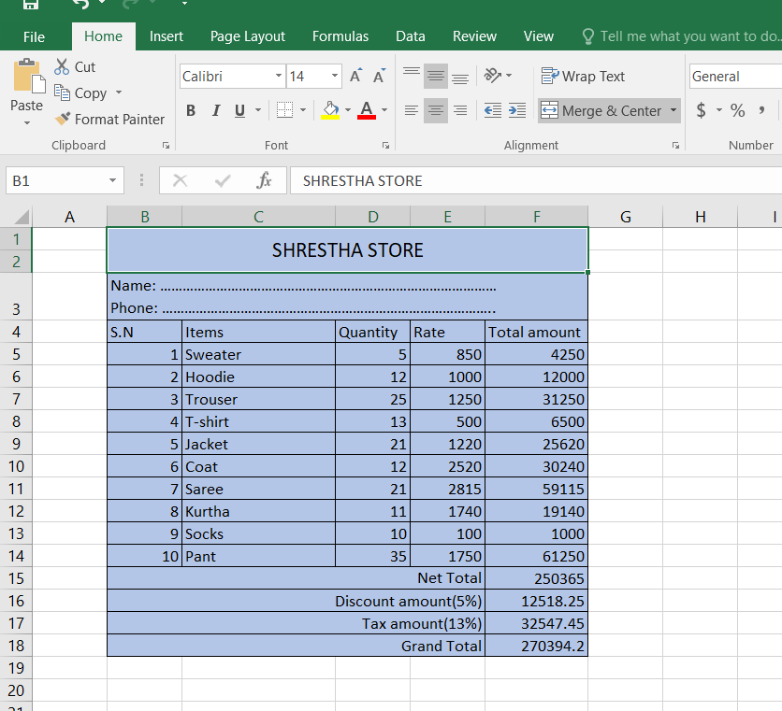
Formulas used:
Total amount= D5*E5
Net Total= SUM (F5:F14)
Discount amount= 5%*F15
Tax amount= 13%*F15
Grand total= F15-F16+F17
10. Create a salary sheet of at least 7 staffs in the office along with graph and chart under the following conditions:
- Enter at least three allowances and deduct Pf @20% and Income tax @10%.
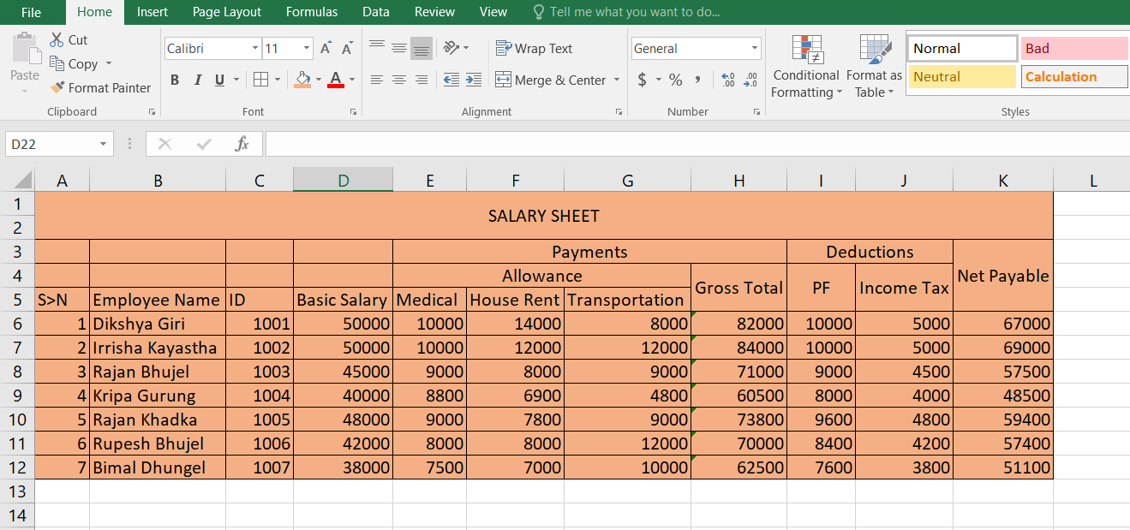

Formulas used:
Grand Total: =SUM (D6:G6)
PF: =20%*D6
Income tax: =10%*D6
Net Payable: =H6-I6-J6
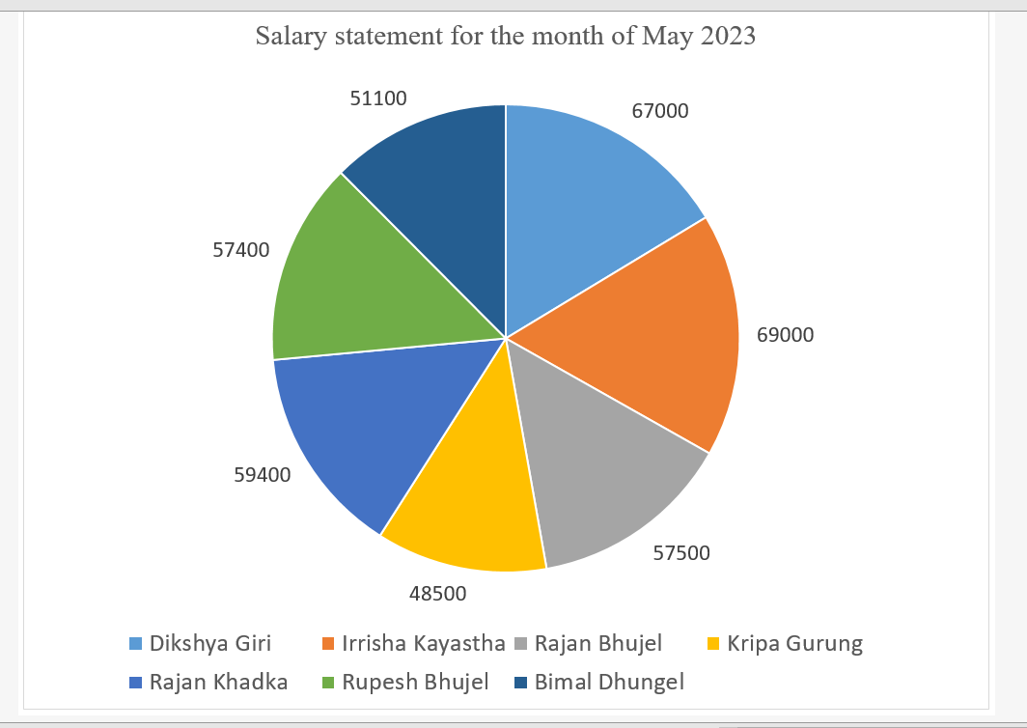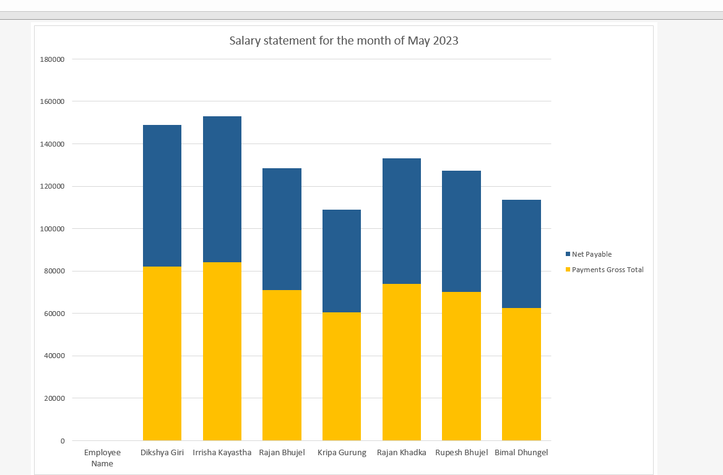

C. Presentation software

11. Prepare a presentation including at least 10 slides of any topic of your choice related to Information Technology.




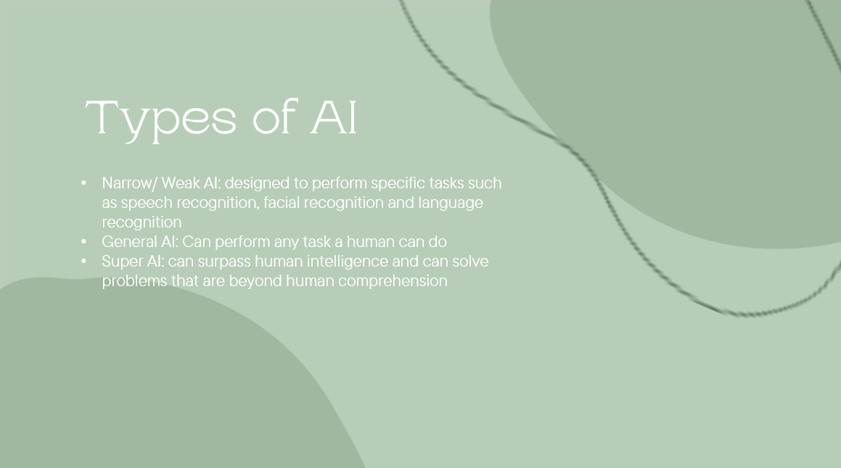

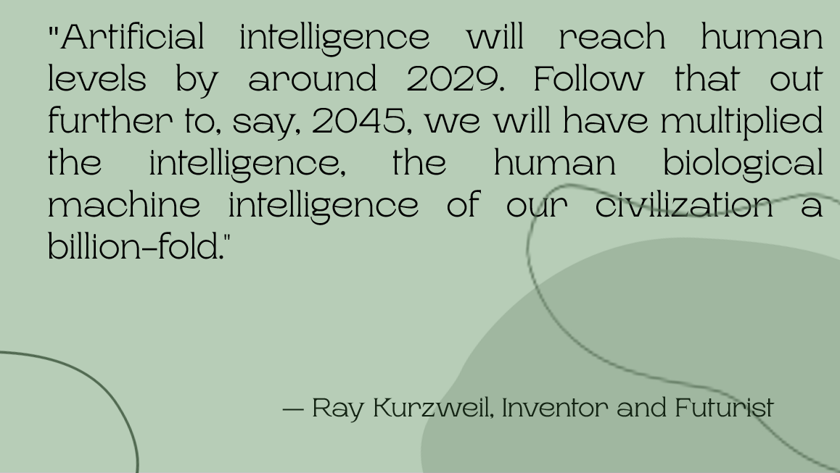

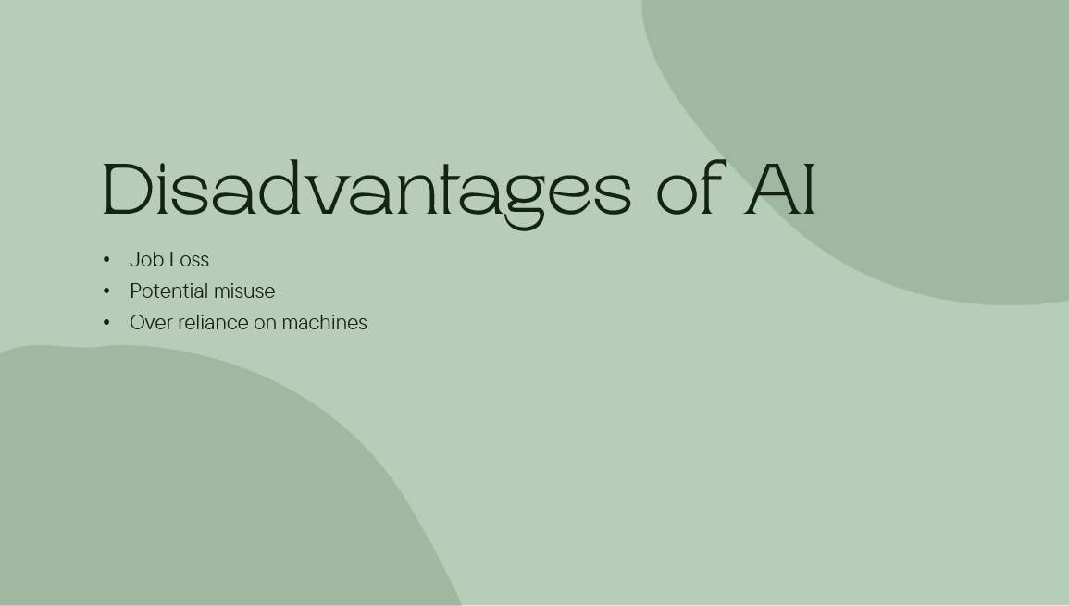





D. Operating system

12. Create a file named “BCA.txt” under your currently created directory. The file should contain the text “We are in computer lab”.

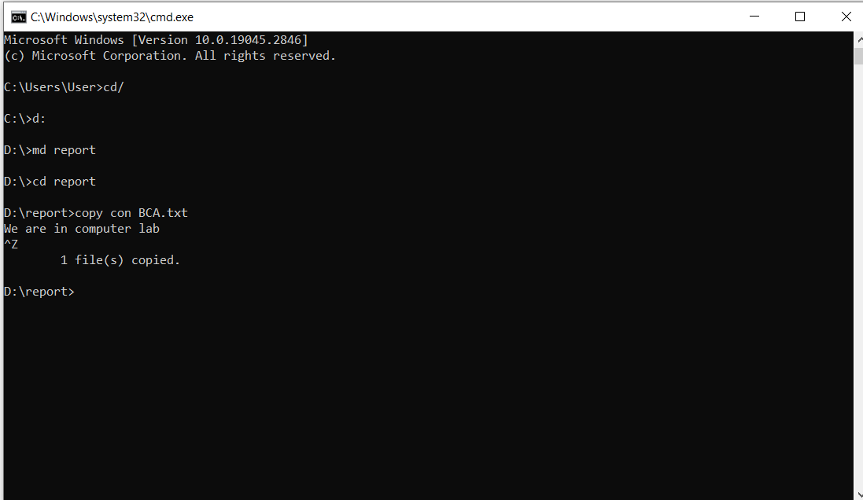

13. Create files and folder according to the below chart.

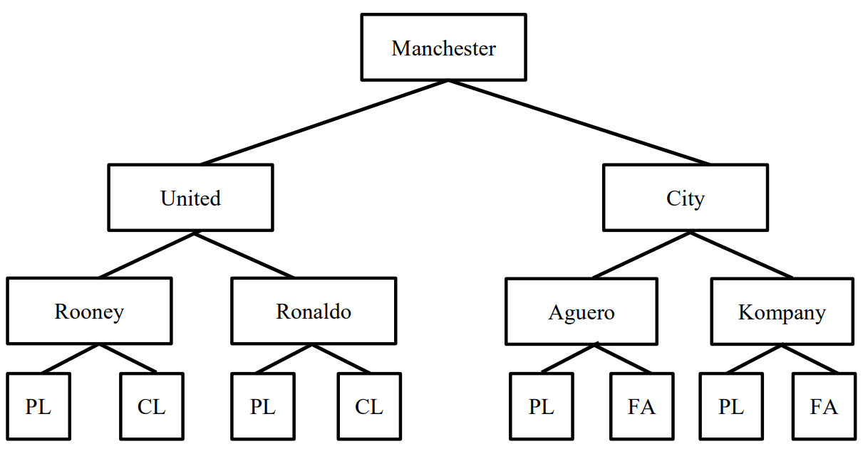

- Manchester is Main Folder/Main Directory.
- United, City, Rooney, Ronaldo, Aguero and Kompany are Sub Folder/Sub Directory.
- PL, CL and FA are files.
